

|  |
| --- |
| HCL Technologies Ltd. |
| Static Map Files (KML) for Delhi Trauma Care centers |

# Overview

KML is a file format used to display geographic data in an Earth browser such as Google Earth, Google Maps, and Google Maps for mobile. KML uses a tag-based structure with nested elements and attributes and is based on the XML standard. All tags are case-sensitive and must appear exactly as they are listed in the [KML Reference](https://developers.google.com/kml/documentation/kmlreference). The Reference indicates which tags are optional. Within a given element, tags must appear in the order shown in the Reference.

A set of KML files are created for Delhi Trauma care hospitals in KML file format. This doc provides the list of such hospitals and then usage details of KML files.

# Trauma care Hospitals (Delhi)

**List of Trauma care hospitals in Delhi, Map files for these are provided**

1. **AIIMS Campus, Ansari Nagar East**
2. **Apollo Hospital Indraprastha**
3. **Batra Hospital**
4. **Deen Dayal Upadhyay Hospital**
5. **Dr. Hedgewar Arogya Sansthan**
6. **Dr. Ram Manohar Lohia Hospital**
7. **Fortis Hospital**
8. **Govind Ballabh Pant Hospital**
9. **GTB Hospital**
10. **Guru Gobind Singh Government Hospital**
11. **Lal Bahadur Shastri Hospital**
12. **Lok Nayak Jai Prakash Narayan Hospital**
13. **Max Hospital**
14. **Mool Chand Hospital**
15. **Sanjay Gandhi Memorial Hospital**
16. **Sardar Vallabh Bhai Patel Hospital**
17. **Sir Ganga Ram Hospital**

# Open KML file Using Google Map Engine

As shown in below image google maps engine provides an option to open KML file. Import option is there to open KML file.

KML file on local drive can be opened in Google map engine manually via the ‘Import’ option.

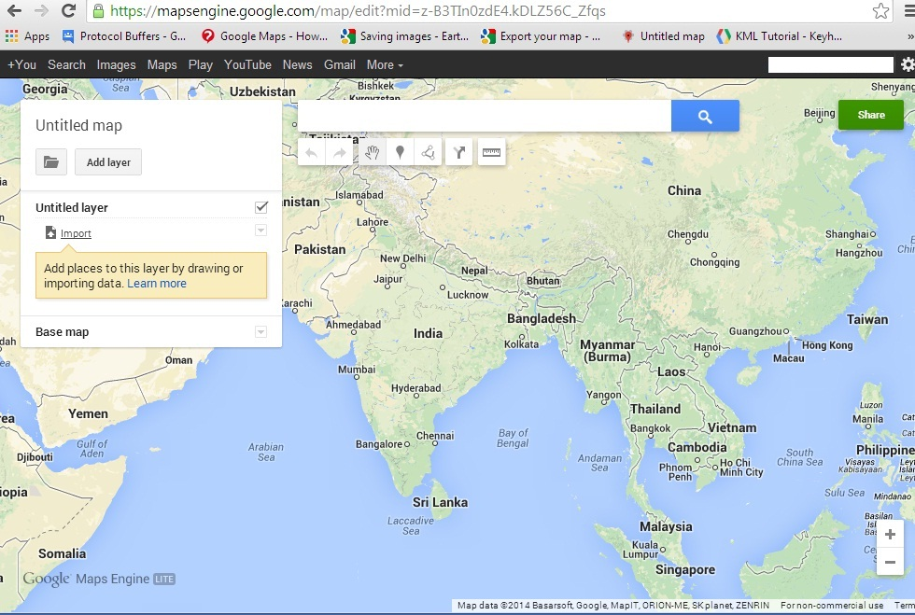

# Open KML File Using HTML

An HTML file can be used to open KML file, using CSS and JavaScript.

KML file should be hosted on public server.

Example:

<!DOCTYPE html>

<html>

<head>

<style>

#map_canvas {

width: 500px;

height: 400px;

}

</style>

<script src="https://maps.googleapis.com/maps/api/js"></script>

<script>

/**

* @fileoverview Sample showing capturing a KML file click

* and displaying the contents in a side panel instead of

* an InfoWindow

*/

var map;

var src = 'https://developers.google.com/maps/tutorials/kml/westcampus.kml';

/**

* Initializes the map and calls the function that creates polylines.

*/

function initialize() {

map = new google.maps.Map(document.getElementById('map_canvas'), {

center: new google.maps.LatLng(-19.257753, 146.823688),

zoom: 2,

mapTypeId: google.maps.MapTypeId.TERRAIN

});

loadKmlLayer(src, map);

}

/**

* Adds a KMLLayer based on the URL passed. Clicking on a marker

* results in the balloon content being loaded into the right-hand div.

* @param {string} src A URL for a KML file.

*/

function loadKmlLayer(src, map) {

var kmlLayer = new google.maps.KmlLayer(src, {

suppressInfoWindows: true,

preserveViewport: false,

map: map

});

google.maps.event.addListener(kmlLayer, 'click', function(event) {

var content = event.featureData.infoWindowHtml;

var testimonial = document.getElementById('capture');

testimonial.innerHTML = content;

});

}

google.maps.event.addDomListener(window, 'load', initialize);

google.maps.event.addDomListener(window, 'load', initialize);

</script>

</head>

<body>

<div id="map_canvas"></div>

</body>

</html>

# Open KML File Using URL

A URL can be used to open KML file.

KML file should be hosted on public server.

Example:

<http://maps.google.com/maps?q=http://econym.org.uk/gmap/example1.kml>

# Creating a KML File

[Google Map Engine](https://mapsengine.google.com/map/) provides features to create and save Map as KML file on our local drive.

1. Once logged in on google map engine, you find an option “create a new map”, as shown in below image:

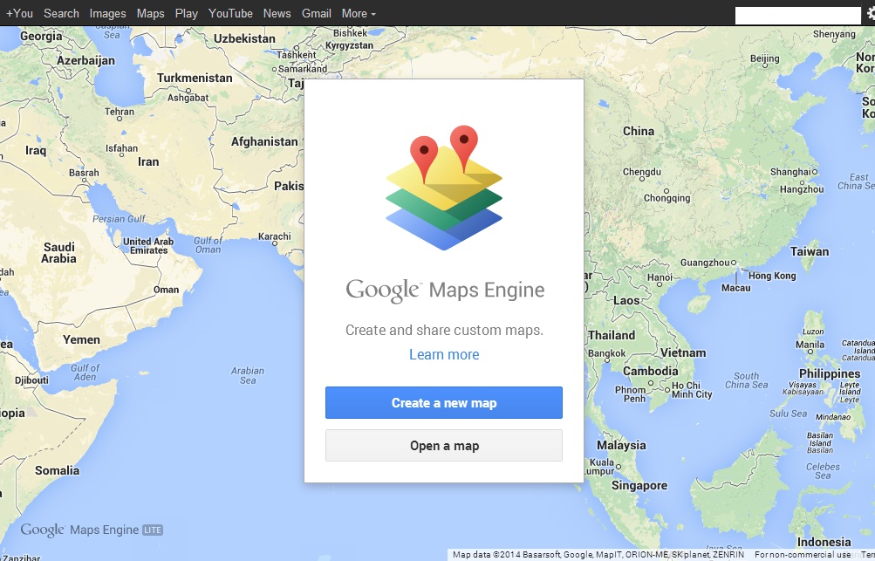

1. After choosing this option, you can search and save points, as many as you want to, on the map.
2. You will find an option “Export” to save map as KML file, as shown in below image:

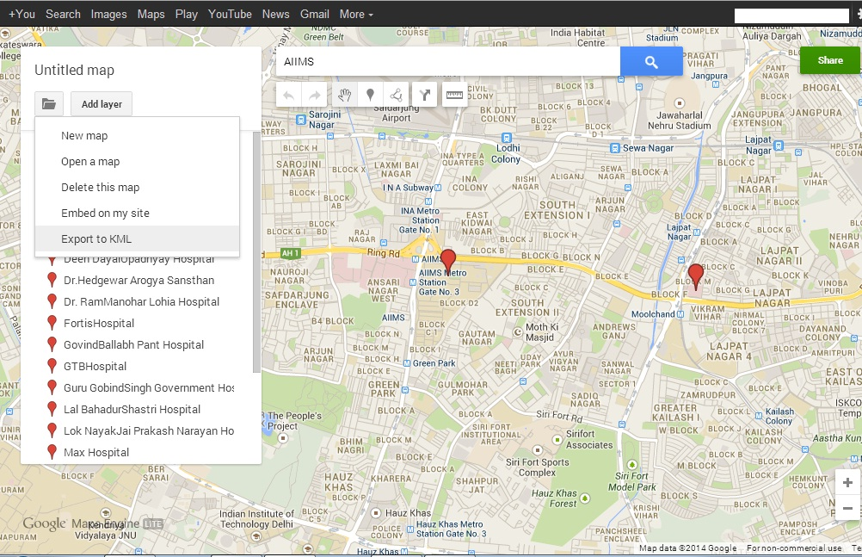

**~~~ End of doc ~~~**